A note to teachers:

Purpose of this form:

The following sample SSEP student permission form has been designed to support teachers’ administrative obligations related to EOTC with a view to creating a single parental permission form to cover the full year’s SSEP activities.

NOTE: this permission form is neither exhaustive nor prescriptive and will not necessarily fulfill your school’s EOTC policies or procedures. This permission form is therefore intended as an OPTIONAL template schools can use as a base document to adapt according to their individual policies and legal obligations or to include in part, or full, as additional information to support their EOTC documentation.

Disclaimer: Smart Waikato Trust acknowledges that each school has its own EOTC policies, procedures and requirements. It is the responsibility of the school and its staff to adhere to these. As purely a facilitating organisation, Smart Waikato Trust accepts no liability for any incidents, accidents or otherwise that may occur during SSEP activities.
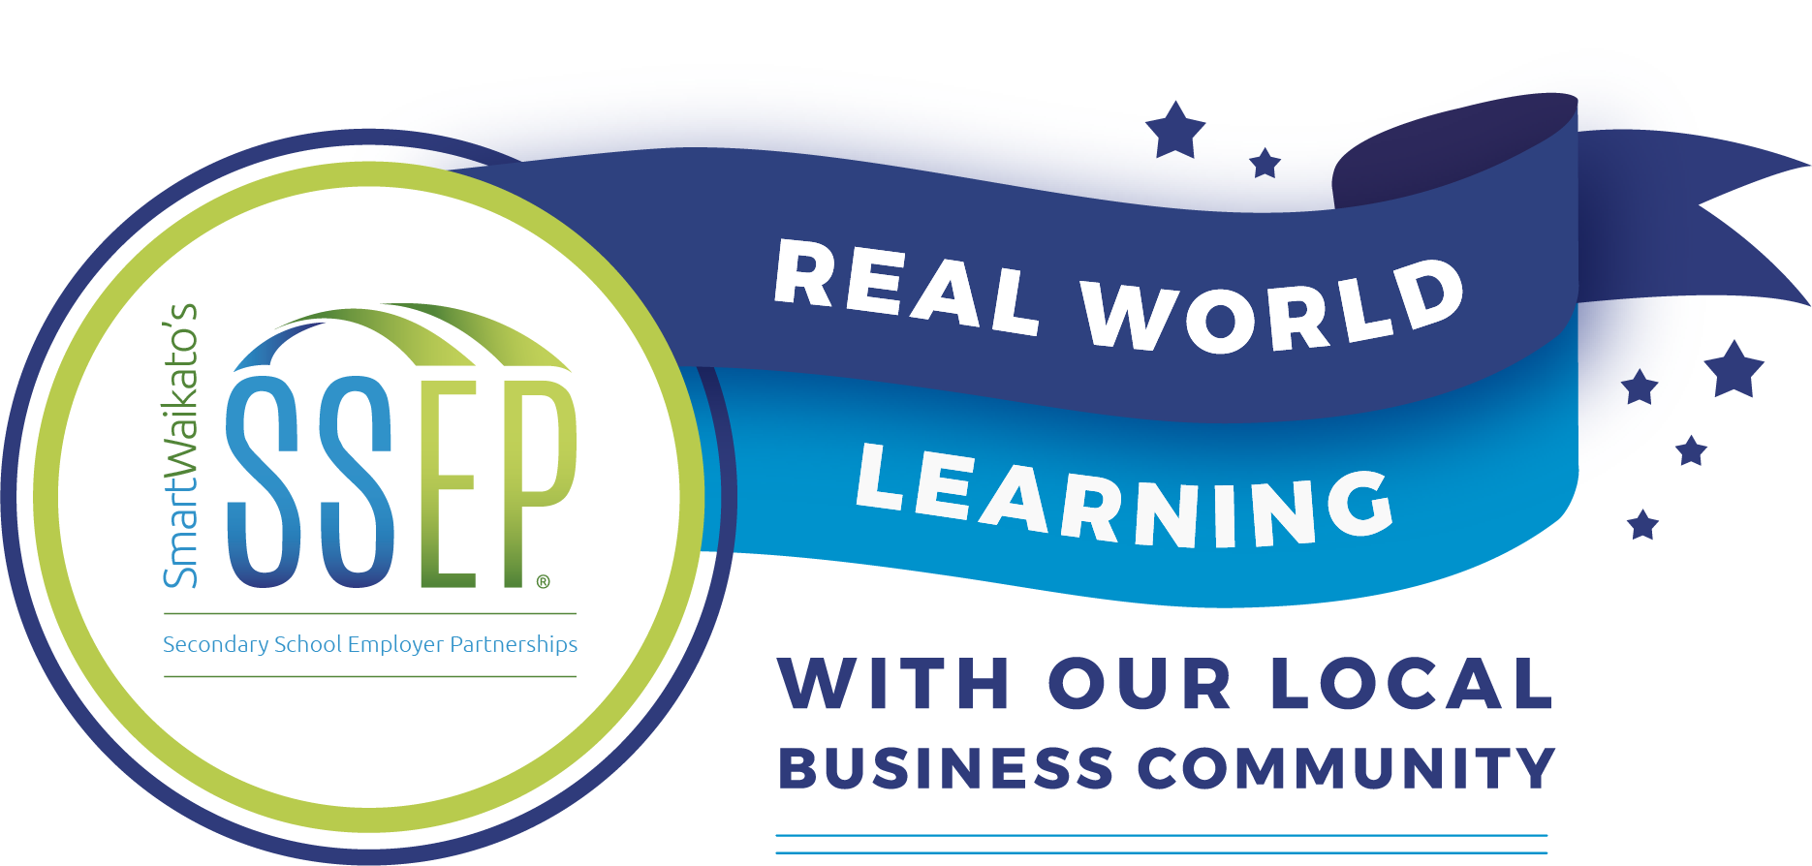
Secondary School-Employer Partnership (SSEP) Programme Information

Smart Waikato’s Secondary School-Employer Partnerships (SSEP) are formal relationships where employers from priority industries in the Waikato region work with teachers at Year 9/10 level to create ‘real world’ learning opportunities for students.

During the SSEP programme business representatives come into the classroom to show how they apply what students are learning in the classroom in their everyday work. Students also go on workplace visits hosted by employer partners to see their classroom learning being applied in real work situations. In addition to gaining a better understanding of the school subject, students meet a range of business representatives from different industries and are introduced to a wide range of careers. This supports students when thinking about their future careers and school subject choices.

SSEP has been identified by Te Waka – the Waikato region’s economic development agency - as key in strengthening linkages between industry and secondary education. Smart Waikato Trust has been working directly with the Ministry of Education to ensure SSEP supports student achievement, retention and transition.

For more about SSEP see http://www.smartwaikato.co.nz/initiatives/ssep/.

This year your child will be involved with SSEP through their subject classes. Our school is partnering with the following organisations:

During SSEP activities both at-school and in the workplace teachers and employer partners will take every precaution to ensure the safety and well-being of your child. As the range of activities will differ depending on the nature of the employer’s business a full risk assessment for each activity will be planned in advance by the teacher and employer involved.

There may be some instances where your child may be required to wear closed-in shoes, long hair tied back or a sunhat for outdoor activities. Any additional safety equipment required (e.g. high viz vests, hard hats, gloves, hair nets etc. will be provided by the school or employer partner). Your child will be involved with some (but not all) of the businesses listed. If you would like further information about the specific activities your child will be involved in, or have any concerns please email their faculty teacher directly at: teacher email
Privacy of information: please note, personal information collected by the school will not be shared with outside parties unless necessary for the health and safety of your child.

Parental Consent, Emergency Contacts and Risk

_________ School Year // In-class and workplace visits with SSEP employer partners (see details attached).

PARTICIPANT INFORMATION FORM
Student Name: _______________________________
Telephone: __________________________________ Mobile: _________________________________
Family Doctor Name: __________________________ Telephone: _____________________________
Medic Alert number (if applicable): ______________________
THIS FORM MUST BE TAKEN ON THE EVENT. A COPY SHOULD BE RETAINED BY THE SCHOOL CONTACT.

EMERGENCY CONTACT DETAILS (please provide at least 2 sets of contact details)
Contact 1: Emergency Contact (Parent/Caregiver)
Name: ______________________________________ Relationship: _____________________________
Address: ____________________________________________________________________________
Home Phone: ________________________________ Mobile: _________________________________
Contact 2: Alternative contact
Name: ______________________________________ Relationship: _____________________________
Address: ____________________________________________________________________________
Home Phone: ________________________________ Mobile: _________________________________

To be read and signed by adult participant or parent/caregiver of child participant.
PARENTAL CONSENT
I agree to my child taking part in SSEP activities with the following employer partners:

Business Name | Yes/No | Business Name | Yes/No
- I have received sufficient information on which to base a decision and I agree to my child’s participation in the activities described.
- I acknowledge the need for my child to follow health and safety guidelines of the teachers/employers, to wear appropriate clothing for the activities and to behave responsibly.
- I give permission for photos/video images that may include my child engaging in SSEP activities may be used for case study or promotional purposes
Health profile and medical consent form
Privacy of information: please note, personal information collected by the school will not be shared with outside parties unless necessary for the health and safety of your child.

Student Name:

Medic Alert number (if applicable):

1. Please highlight if your child has any of the following:

Heart condition Epilepsy Asthma
Diabetes ADHD Fits of any type
Dizzy spells Other (Please specify

ACKNOWLEDGEMENT OF RISK

- I have read the SSEP information sheet, and I understand that there are risks associated with involvement in school Education Outside of the Classroom (EOTC) events and that these risks cannot be completely eliminated.
- I understand that the school and employer partners will identify any foreseeable risks or hazards and implement correct management procedures to eliminate, isolate or minimise those hazards.
- I understand my child has been involved in the development of safety procedures. I will do my best to ensure that my child follows these procedures.
- I know that I am able to ask any questions of the school about the activities my child will be involved in, to gain a better understanding of the risks involved. My child and I both understand that they may withdraw from an activity if they feel at risk. This must be done in consultation with the person in charge.
- I understand that the school and employer partners do not accept responsibility for loss or damage to personal property and that it is my responsibility to check my own insurance policy.

Name:

Signature: Date:

Privacy of information: please note, personal information collected by the school will not be shared with outside parties unless necessary for the health and safety of your child.
2. Is your child currently taking medication? Please highlight: Yes No

If YES, please state: Health condition/s:

Name of medication/s/ dosage and time/s taken:

Other Treatment:

3. Has your child had any major injuries or illness in the last six months that may limit full participation in any activities? Please highlight: Yes No

If YES, please state the injury/illness:

4. Is your child allergic to any of the following? Please highlight: Yes No

Prescription medication Food Insect bites/stings

Other allergies

Please specify treatment required:

5. When was your / your child’s last tetanus injection?

6. Outline any dietary requirements:

7. Do you want pain/flu medication to be given if necessary? Please highlight: Yes No

8. To the best of your knowledge. Has your child been in contact with any contagious or infectious diseases in the last four weeks? Please highlight: Yes No

If YES, please give brief details:

9. Is there any information the staff should know to ensure the physical and emotional safety of you/your child? (For example cultural practices; disability; anxiety; about heights/darkness/small spaces; pregnancy; behaviour or emotional problems). Please tick. Yes No

If YES, please state or attach the information. ________________________________________________
Privacy of information: please note, personal information collected by the school will not be shared with outside parties unless necessary for the health and safety of your child.
10. In the event your child is near water, is your child a competent swimmer?
(Can swim 50m / tread water / confidently in deep water). Please highlight. Yes No

- I agree that if prescribed medication needs to be administered, a designated adult will be assigned to do this. I will ensure that prescribed medication is clearly labelled, securely fastened and handed to the designated adult with instructions on its administration.
- I will inform the school as soon as possible of any changes in the medical or other circumstances between now and the commencement of the event.
- I agree to my child/myself receiving any emergency medical, dental, or surgical treatment, including anaesthetic or blood transfusion, as considered necessary by the medical authorities present.
- Any medical costs not covered by ACC, or a community service card will be paid by me.
- If my child is involved in a serious disciplinary problem, including the use of illegal substances and/or alcohol, or actions that threaten the safety of others, s/he will be sent home at my expense.

To be read and signed by adult participant or parent/caregiver of child participant.

Name:

Signature:
Privacy of information: please note, personal information collected by the school will not be shared with outside parties unless necessary for the health and safety of your child.

Date:

